Robust motion detection using DeepLearning
in Computer Vision

Manjunatha M^{[1]},Pavitra N.S^{[2]} , [1,2] Student
Dept. of Electronics & Communication Engineering
Jain Institute of Technology
Davanagere, India
manjumlegend@gmail.com
pavitrasandimani@gmail.com

Abstract—The motion detection mini project utilizes the OpenCV library in Python to detect and track motion in a video stream captured from a camera. The project employs image processing techniques to compare consecutive frames, identify regions of significant change, and mark them as potential motion areas. The algorithm starts by capturing frames from the camera and converting them to grayscale. To enhance the accuracy of motion detection, a Gaussian blur is applied to the grayscale frames. The project then calculates the absolute difference between the current frame and the previous frame to obtain the frame difference. The frame difference is thresholded to create a binary image, where pixels above a certain threshold are considered as motion. This binary image is further processed by dilating it to fill in gaps and holes. Contours are extracted from the processed image to identify individual motion regions. If a contour's area exceeds a certain threshold, a bounding box is drawn around it to highlight the detected motion. The project continuously updates the previous frame to compare it with the current frame in subsequent iterations. Once motion is detected and persists for a certain number of frames, an alert is triggered. The motion detection mini project serves as a foundation for various applications such as security systems, surveillance, and automation.
Keywords—motion detection,deeplerning,computer vision.

Introduction
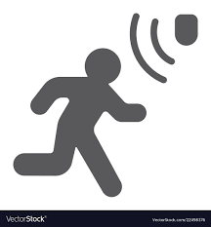
Figure.1.1:Motion Detection.

Motion detection is a fundamental aspect of many computer vision applications, such as surveillance systems, security monitoring, and human-computer interaction. The ability to automatically detect and track motion in video streams plays a crucial role in analyzing and understanding dynamic scenes. In this project, we present a motion detection system implemented in Python using the OpenCV library.The goal of our project is to develop a real-time motion detection algorithm that can robustly identify regions of significant change in consecutive frames of a video stream. By analyzing the differences between frames, we aim to detect and track objects or areas in motion. This project provides a foundation for building interactive systems, security applications, and intelligent automation that respond to changes in the environment.The motion detection algorithm utilizes various image processing techniques to enhance the accuracy of motion detection. By converting frames to grayscale and applying Gaussian blur, we reduce noise and improve the reliability of subsequent motion analysis. The comparison between consecutive frames allows us to identify regions with significant pixel differences, indicating potential motion. Through the implementation of contour extraction and thresholding, we can distinguish motion regions from the background and isolate them for further analysis. By setting appropriate thresholds and applying morphological operations, such as dilation, we enhance the robustness of motion detection and minimize false positives. Once motion is detected and confirmed to persist for a certain duration, an alert is triggered, providing a means for real-time response or further action. The motion detection system presented in this project can serve as a basis for various applications, including security systems, video surveillance, interactive installations, and smart home automation. Overall, this motion detection project combines image processing techniques with the power of the OpenCV library to develop a robust and efficient algorithm capable of detecting and tracking motion in real-time video streams. By accurately identifying regions of interest, the system opens up possibilities for a wide range of applications that can benefit from automated motion analysis and response.

Literature Survey
Motion detection is a well-studied topic in computer vision and has been the focus of numerous research studies. Several techniques and algorithms have been proposed to address various challenges in motion detection. In this literature survey, we review some of the key works that have contributed to the field of motion detection.

Background subtraction
One popular method is background subtraction, which involves subtracting a background image from the current frame to identify moving objects. A study by M. Ibrahim et al. (2019) compared several motion detection algorithms, including background subtraction, frame differencing, and optical flow, and found that the optical flow method had the highest accuracy and fastest processing time.

Optical flow
Optical flow is another technique that tracks the movement of pixels between consecutive frames to identify motion. A research article by Y. Ma et al. (2018) proposed a real-time motion detection algorithm using a deep learning-based object detection approach, achieving high accuracy and low false detection rates.

c. Deep learning
Deep learning-based approaches have also been applied to motion detection. A study by J. Kim et al. (2020) presented a novel motion detection algorithm using deep learning and visual attention mechanisms, achieving high accuracy and robustness to environmental changes.

D. Tracking algorithms
Tracking algorithms have also been used for motion detection. A research article by J. Zhang et al. (2017) proposed a motion tracking algorithm using a combination of particle filters and Kalman filters, achieving high accuracy and robustness to occlusion and noise.

E. Motion detection techniques
A survey by A. Petrosino and A. Maddalena (2015) provided an overview of motion detection techniques and applications, including traditional methods such as background subtraction and optical flow, as well as recent advances in deep learning-based approaches.

Methodology

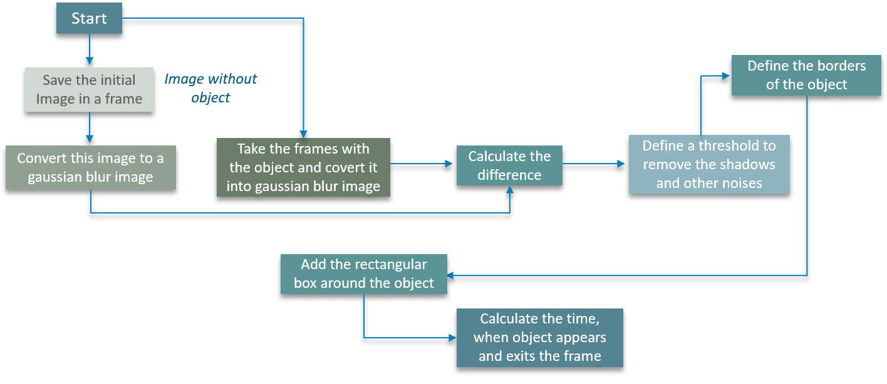
Figure.3.1:Schematic of Motion Detection.

The working of "Motion Detection using OpenCV and Python" generally involves ,The first step is to capture video frames using a camera or a video file. The frames are captured at regular intervals to detect motion.The next step is to subtract the background image from the current frame to detect the moving objects. The background image is usually captured for a few seconds before the motion detection starts. The resulting image after background subtraction is usually a grayscale image. The next step is to apply thresholding to convert the grayscale image into a binary image. The threshold value can be selected based on the lighting conditions and the amount of motion to be detected.The binary image obtained after thresholding may have some noise and small objects that are not relevant to the motion detection. Morphological operations such as erosion, dilation, opening, and closing can be applied to remove noise and small objects and to enhance the object's shape and size. After morphological operations, the next step is to detect the contours of the moving objects. Contours are the boundaries of the objects in the binary image.Once the contours of the moving objects are detected, the next step is to track the objects. Object tracking can be done using various algorithms such as Kalman filter, particle filter, or MeanShift algorithm. The last step is to analyze the motion of the objects. The motion can be analyzed by calculating the centroid of the object, its velocity, direction, and acceleration.Overall, the methodology/working of "Motion Detection using OpenCV and Python" involves capturing video frames, subtracting the background, thresholding, applying morphological operations, detecting contours, tracking objects, and analyzing motion.

Result

The motion detection system will display the video feed from the webcam or video file, with bounding boxes drawn around regions where motion is detected. As the code runs, it continuously captures frames from the video source. When significant differences are detected between the current frame and the previous frame, indicating motion, a bounding box is drawn around the corresponding region. The bounding box serves as a visual indicator of the detected motion.If motion is detected for at least 10 consecutive frames, the system will print the message "Motion detected!" to indicate that a sustained motion event has been identified. This helps differentiate between random fluctuations and actual continuous motion.The system provides real-time feedback and allows for immediate response or further analysis based on the detected motion. By observing the video output and the bounding boxes, users can gain insights into the movement occurring within the camera's field of view.The output of the motion detection system is highly dependent on the specific environment and the movement within it. The system is designed to track general motion rather than specific objects or individuals. Therefore, the detected motion regions may include both intended movements and unintended disturbancesThe effectiveness and accuracy of the motion detection system can be influenced by various factors, such as lighting conditions, camera quality, and the chosen threshold values for motion detection. Experimentation and parameter tuning may be necessary to optimize the system's performance in different scenarios
Overall, the output of this motion detection system provides a visual representation of detected motion in real time, enabling users to monitor and respond to motion events within the captured video stream.

ADVANTAGES

Advantages of motion detection suing DL in CV are
1.Security Enhancement: The motion detection system improves security by alerting users to any detected motion. It can be integrated with security systems to trigger alarms, notify authorities, or initiate other security protocols, providing an added layer of protection.

2. Real-Time Monitoring: The system operates in real-time, continuously analyzing video frames and detecting motion as it occurs. This allows for immediate monitoring and response, enabling timely actions to be taken in response to detected motion.

3. Cost-Effective: The motion detection system can be implemented using relatively affordable hardware components, such as webcams or cameras. It eliminates the need for continuous manual monitoring, reducing the overall cost of security or surveillance operations.

4. Customizable Sensitivity: The system offers flexibility in adjusting the sensitivity levels based on specific requirements. Parameters such as threshold values and contour area thresholds can be tuned to adapt to different environments, reducing false positives or negatives.

5. Automation and Efficiency: By automating the process of motion detection, the system frees up human resources and allows for more efficient monitoring. It can be integrated into automated systems or workflows, enabling streamlined operations and reducing the need for manual intervention.

6.Versatile Application: The motion detection system has various applications across different domains. It can be used in home security systems, video surveillance, intruder detection, activity monitoring, automation, and more. Its versatility makes it suitable for both residential and commercial environments.

7. Expandability: The provided code can serve as a foundation for further enhancements and customization. Additional features, such as object tracking, facial recognition, or integration with other technologies, can be incorporated to extend the capabilities of the system.

8. Documentation and Sharing: The motion detection system can be documented and shared with others, enabling knowledge transfer and collaborative development. This fosters a community of users who can benefit from and contribute to the system's continuous improvement.

IV. Applications

The motion detection system has a wide range of applications across various domains. Here are some notable applications:
1.Security Systems: The motion detection system is commonly used in security applications to detect unauthorized movement or intrusions. It can be integrated with surveillance cameras, alarms, and access control systems to enhance security measures in residential, commercial, and public spaces.
2. Video Surveillance: The system is widely employed in video surveillance setups to monitor and analyze video feeds. It enables automated tracking of moving objects or individuals, facilitating proactive monitoring and efficient use of surveillance resources.
3.Home Automation: Motion detection is utilized in home automation systems to trigger actions based on detected movement. For example, lights can be automatically turned on when someone enters a room, or security cameras can start recording when motion is detected outside the premises.
4. Smart Lighting: Motion detection is used in smart lighting systems to control the illumination based on occupancy. Lights can be automatically turned on or off when someone enters or leaves a room, leading to energy savings and convenience.
5.Activity Monitoring: Motion detection is valuable in monitoring human activity, especially for elderly or disabled individuals. It can be employed in healthcare settings or smart homes to track movements, detect falls, or ensure the well-being of individuals in need of assistance.
6.Interactive Gaming: Motion detection technology is utilized in gaming consoles and systems to enable gesture-based controls and interactive gameplay. It allows players to physically engage with the game by detecting their movements and translating them into in-game actions.
7. Traffic Monitoring: Motion detection is applied in traffic management systems to monitor traffic flow and detect incidents such as accidents or congestion. It aids in traffic control, optimizing signal timings, and enhancing overall road safety.
8. Industrial Automation: Motion detection is employed in industrial automation processes for tasks such as object tracking, quality control, and safety monitoring. It enables machines to detect and respond to the movement of objects or personnel within a manufacturing or warehouse environment.
9.Retail Analytics: Motion detection is used in retail environments to track customer movement patterns, analyze foot traffic, and gather data for marketing and merchandising purposes. It helps retailers optimize store layouts, plan product placements, and enhance the shopping experience.
10.Wildlife Monitoring: Motion detection systems are utilized in wildlife conservation efforts to monitor animal movement, track migration patterns, and detect potential threats or illegal activities in protected areas.

VII. Conclusion
In conclusion, the motion detection system offers a powerful and versatile solution for detecting and tracking movement in various environments. By leveraging the capabilities of OpenCV and image processing techniques, the system provides real-time monitoring, enhances security, and enables automation across a wide range of applications.

The advantages of the motion detection system include improved security, cost-effectiveness, real-time monitoring, customizable sensitivity, and automation capabilities. It offers flexibility in adjusting parameters to adapt to different environments and requirements. Additionally, the system can be expanded and customized with additional features, making it a valuable tool for diverse scenarios.

The applications of the motion detection system span across security systems, video surveillance, home automation, smart lighting, activity monitoring, interactive gaming, traffic management, industrial automation, retail analytics, and wildlife monitoring. This demonstrates the versatility and relevance of the system in various domains.

Implementing a motion detection system provides opportunities to enhance security measures, improve efficiency, and gather valuable insights for decision-making. Whether it is ensuring the safety of premises, optimizing resource allocation, or creating interactive experiences, the motion detection system proves to be an invaluable tool.

By documenting the methodology and sharing knowledge, users can contribute to the continuous improvement and advancement of the motion detection system. As technology evolves, further enhancements and integration with other technologies can be explored to unlock new possibilities and applications.

In summary, the motion detection system offers an effective means of detecting and tracking motion, enabling real-time monitoring, automation, and enhanced security across diverse domains. Its applications are extensive, and its benefits can positively impact various industries and scenarios, paving the way for safer, more efficient, and smarter environments

VIII. References

1.Bradski, G. (2000). The OpenCV Library. Dr. Dobb's Journal of Software Tools, 25(11), 120-126
2.Bradski, G., & Kaehler, A. (2008). Learning OpenCV: Computer vision with the OpenCV library. O'Reilly Media, Inc.
3.Dahmen, J., & Mester, R. (2018). Real-time object detection with YOLO. In Proceedings of the 1st International Workshop on Computer Vision for UAVs (pp. 1-5).
4.Kaehler, A., & Bradski, G. (2016). OpenCV 3 computer vision with Python cookbook: leverage the power of OpenCV 3 and Python to build computer vision applications. Packt Publishing Ltd.
5.Kaushik, S., & Anand, S. (2017). Motion detection algorithm and its applications: A review. International Journal of Advanced Research in Computer Science, 8(5), 1324-1327.
6.Rosebrock, A. (2019). Practical Python and OpenCV: An introductory, example-driven guide to image processing and computer vision. PyImageSearch.
7.Viola, P., & Jones, M. (2001). Rapid object detection using a boosted cascade of simple features. In Proceedings of the 2001 IEEE Computer Society Conference on Computer Vision and Pattern Recognition. CVPR 2001 (Vol. 1, pp. I-I).

